- Good evening, we’re a consulting team evaluating whether FoundationDB is a strategic fit for TechRetail’s architecture. Today, TechRetail operates with PostgreSQL shards, Cassandra, and a data warehouse. While each system performs well individually, the combined architecture introduces operational complexity, data duplication, and consistency challenges.

Team Introduction (1 min) — Each member states their name and their role in the project (e.g., “Architecture Lead”, “Consistency Analyst”, “Demo/Comparison Lead”, “TechRetail Evaluator”).
- Helen Nguyen: Project Manager
- Quang Nguyen: Architecture Lead
- Juan Rivera: Consistency Analyst
- Aleksandr Nicolav: Systems Analyst
- Yusuke Yoshinawa: TechRetail Evaluator

System Overview (2 min) — What the system is, who created it, who uses it in production, and the core value proposition. Set the stage for the technical deep dive.
- FoundationDB is a distributed database. It spreads data across multiple machines that work together as one system.
- FoundationDB stores data as an ordered key-value store. Each piece of data has a key, which is like a label, and a value, which is the information stored under that label. The “ordered” part means those keys are kept in sorted order, which helps the system find data efficiently.
- FoundationDB was originally created by FoundationDB, Inc. Today, it’s part of the FoundationDB open-source project under Apple’s stewardship.
- Who uses it in production, FoundationDB is designed for real production environments where a business cannot afford to lose data integrity just because the system is distributed. It is especially useful for applications with heavy read and write workloads. Publicly documented production users of FoundationDB include Snowflake, Wavefront by VMware, and Apple.
- FoundationDB’s core value is that it combines several features that are usually difficult to get together in one database to handle large amounts of data, many users, and machine failures without the whole system breaking.
  - First, it provides ACID transactions. If a transaction has multiple steps, either all of them succeed together or none of them are saved. That is especially important in real applications like banking, e-commerce, or booking systems, where incomplete updates can create serious problems.
  - Second, it supports horizontal scalability, so the system can grow by adding more machines instead of relying on one larger machine.
  - Third, it is fault-tolerant, meaning it can keep operating even when some components fail.
  - And fourth, it supports flexibility, since developers can use FoundationDB in different ways depending on their app without changing its reliable core. They can use it directly as a key-value database for more control, or use a layer that makes it behave more like another type of database, such as a document database.
  - Its architecture reinforces that value by dividing the system into specialized roles, where each role handles a different job. This matters allows different types of work to scale separately, for example, read operations can scale through storage servers, while write operations scale through components like commit proxies, resolvers, and transaction logs.
  - So the deeper point is that FoundationDB is designed so correctness, performance, and scalability are built into the system from the start.

Technical Deep Dive (3–4 min) — Architecture, CAP positioning, consistency model, and scaling approach. This is the core of your presentation. Must include at least one architecture diagram.
- Architecture Overview
FoundationDB uses a decoupled, heterogeneous architecture to provide strict ACID transactions with high scalability. Here is the 1-minute breakdown:
- Storage Engine: It supports multiple engines, including the SSD engine (B-tree based on SQLite), the newer Redwood engine (introduced in version 7.0), and a Memory engine that uses append-only logs for durability.
- Consensus Protocol: The system relies on a majority of Coordinators to elect a Cluster Controller, which acts as the cluster's "root of trust". During recovery, the Master locks "coordinated states" to prevent multiple masters from operating simultaneously, organizing the system into unique "epochs".
- Node Roles: Unlike many databases, FoundationDB uses specialized roles. Coordinators and Cluster Controllers manage cluster health; Proxies and Resolvers handle transaction intake and conflict detection; Transaction Logs ensure durability; and Storage Servers handle the actual data storage.
- Data Partitioning: Data is range-partitioned. A singleton role called the Data Distributor monitors storage servers and automatically moves these key ranges to ensure the workload is evenly balanced across the cluster. Clients cache this mapping to communicate directly with the correct storage servers.
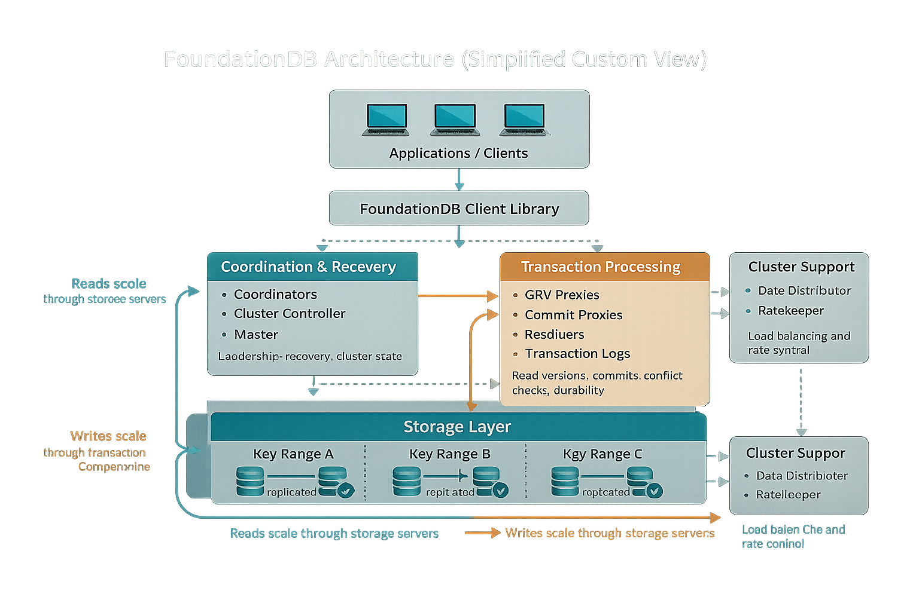

Slide: CAP + SQL:

FoundationDB is a CP system, meaning it prioritizes consistency and partition tolerance.
In case of a network partition, only the majority of nodes can process writes, while minority nodes become unavailable to prevent inconsistencies. This is like PostgreSQL, which also focuses on strong consistency, but PostgreSQL doesn’t scale horizontally as well.
On the other hand, Cassandra is an AP system, prioritizing availability and allowing eventual consistency. So overall, FoundationDB sits in the middle - it provides strong consistency like PostgreSQL, but with the scalability of distributed systems.

Unlike PostgreSQL, FoundationDB does not support SQL natively. Instead, it uses a key-value model, and SQL functionality must be added through external layers like the Record Layer.
This means features like joins, window functions, and stored procedures are not directly available. Because of this, developers must design data models based on access patterns, similar to Cassandra. While this reduces flexibility for ad-hoc queries, it improves performance and scalability in distributed environments.

Slide: Scaling Model
- Automatic range-based sharding
- Key ranges distributed across servers
- Rebalancing is automatic when nodes added/removed
- vs Part 2: manual sharding = hot shards, uneven data

Slide: Consistency & Transactions

- Full ACID transactions with strict serializability
- Optimistic concurrency control
- Active Disk Paxos for fault tolerance
- vs PostgreSQL: strong but single-node | vs Cassandra: fast but weaker consistency

TechRetail Evaluation (2 min) — Which Part 1–3 component could this system replace? What are the trade-oﬀs? Must include a comparison table.
- FoundationDB is the strongest replacement for the sharded sales layer from Part 2.
  - Splitting data into Southeast and Northeast shards led to uneven distribution, hot shards, and required application-level logic for cross-shard queries. But I don’t recommend replacing Cassandra and PostgreSQL. Here is the why with details.
- Comparison table
  - FoundationDB is less complex by automatically distributing and rebalancing data across nodes.

- system perspective
  - docker-compose setup: Instead of running multiple PostgreSQL shard containers, we would run one FoundationDB cluster with several nodes, and the application would connect to a single logical database instead of multiple shard endpoints.
  - As a result, ETL pipeline would no longer need to extract from multiple shards and merge the data, reducing complexity.
  - Which means, instead of querying each shard separately and combining results manually, the application could issue a single logical query across the distributed system.
- Tradeoff
  - No full SQL support out of the box. so, query functionality may require additional layers or custom development.
  - Weaker fits for Cassandra ingestion, since Cassandra is optimized for extremely high write throughput, while FoundationDB prioritizes strong consistency.
  - Finally, it cannot replace the PostgreSQL warehouse, which relies on SQL joins and analytical queries.

Although implementing FoundationDB requires upfront investment in engineering, migration, and infrastructure, the long-term value can strongly outweigh the cost because it reduces the need to manage separate systems like PostgreSQL shards, Cassandra, and multiple synchronization pipelines between them. By combining strong ACID transactions, automatic horizontal scaling, and high write throughput in one distributed platform, FoundationDB can lower operational complexity, reduce data inconsistency risks, and cut the ongoing cost of maintaining multiple databases and integration layers. For a company, the real business case is not just buying another database, but investing in a simpler, more scalable architecture that can improve reliability, support growth, and reduce technical overhead over time.

Conclusion (30 sec) — Key takeaway: when would you recommend this system and when would you not?
Recommend FoundationDB when you need flexible data models via the Layer concept and linear scalability where reads and writes can grow independently. Avoid it for long-running transactions exceeding five seconds or workloads with high data conflicts that cause frequent aborts. It is also not ideal if you cannot design idempotent transactions, which are required to safely handle commit_result_unknown errors during system recoveries.

Q&A (2 min) — Questions from the class and instructor.

